**TCSiON INTERNSHIP PROJECT REPORT**

**Functional Testing using Selenium WebDriver**

**“PHP TRAVELS”**

***CREATED BY****:* AKHIL.K

**PURPOSE**

This document explains the various activities performed as part of Testing of <https://phptravels.com> application

**Application Overview**

PHPTRAVELS is an online reservation solution that acts as your work of travel platform. It functions as a combination of both booking and reporting programs and can work on any device. With it we can make pages for content and travel guides. The site has 4 parts ‘Customer Front-End, Agent Front-End, Admin Back-End and Supplier Back -End. There are several modules in each parts like Booking, Payment, Flights, Tours, Visa, Hotels… which are integrated to fulfill the purpose.

**Testing Scope**

**a)** In Scope Functional Testing for the following modules are in Scope of Testing

**Customer Front-End**

* Login
* My Bookings
* Add Funds
* My Profile
* Logout
* Payment using PayPal
* Displaying the Voucher for booking
* Update Address in My Profile

**Agent Front-End**

* Login
* My Bookings
* Add Funds
* My Profile
* Logout
* Home
* Hotels
* Flights
* Tours
* Visa
* Blog
* Offers
* Search hotels by city
* Update the currency from USD to IN

**Admin Back-End**

* Login
* Bookings
* Display of booking invoice for successful payments
* Delete ,cancelled bookings
* Change the booking status from ‘pending to confirmed and verify the count in dashboard
* Website link clicking

**Supplier Back-End**

* Login
* Check the Dashboard view and check the text ‘Sales Overview and Summary’
* Check whether Revenue Breakdown is displayed
* Change the booking status from pending to confirmed and verify the count in dashboard
* Flight,Visa,Tours,Bookings links verification

**b) Out of Scope:** Performance Testing was not done for this application.

|  |  |
| --- | --- |
| **Overall progress of the QA cycle(Onetime, delayed,  Stopped)** | **On time** |
| **Total number of test cases** | 26 |
| **Number of testers** | 1 |
| **Test cycle duration** | 03/01/2023  To  14/02/2023 |

**METRICS**

|  |  |  |
| --- | --- | --- |
| **Dailey Report** | **Status for 05/02/2023** |  |
|  |  |  |
|  | **Number of test cases planned** | 5 |
|  | **Number of test cases executed** |  |
|  | **Number of test cases executed overall** | 5 |
|  | **Number of defects encountered today** |  |
|  | **Number of defect encountered so far** |  |
|  | **Number of critical defects- still open** |  |

|  |  |  |
| --- | --- | --- |
| **Overall status** |  |  |
|  | **Number of test cases planned** | 26 |
|  | **Number of test cases executed (A=automation,M=manuel)** | M=51, A=26 |
|  |  |  |
|  | **Number of test cases executed (%) (A=automation,M=manuel)** | M=99%,A=90% |

|  |  |  |  |
| --- | --- | --- | --- |
| **Test cases**  **Planned**  **(a=automation)**  **(m=manual)** | **Test cases**  **executed**  **(a=automation)**  **(m=manual)** | **TCs**  **Pass**  **(a=automation)**  **(m=manual)** | **Tcs**  **Failed**  **(a=automation)**  **(m=manual)** |
| 51(m)  26(a) | 51(m)  26(a) | 46(m)  18(a) | 5(m)  8(a) |

|  |  |  |  |  |
| --- | --- | --- | --- | --- |
| **Critical** | **Major** | **Medium** | **Cosmetic** | **Total** |
| 4 | 1 | 0 | 3 | 8 |

* **Number of defects identified and their severity**

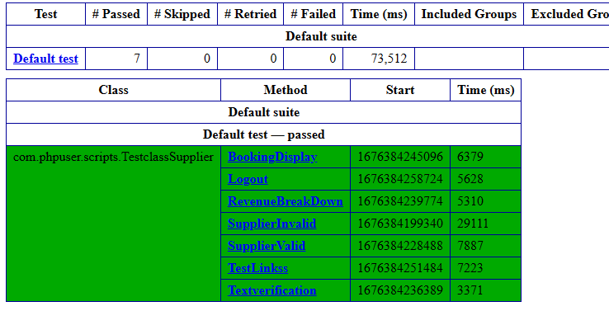

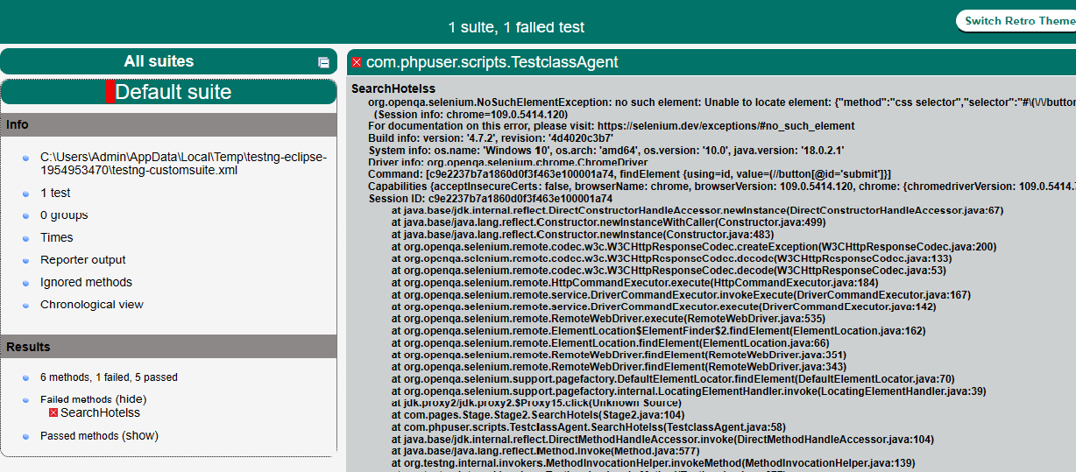

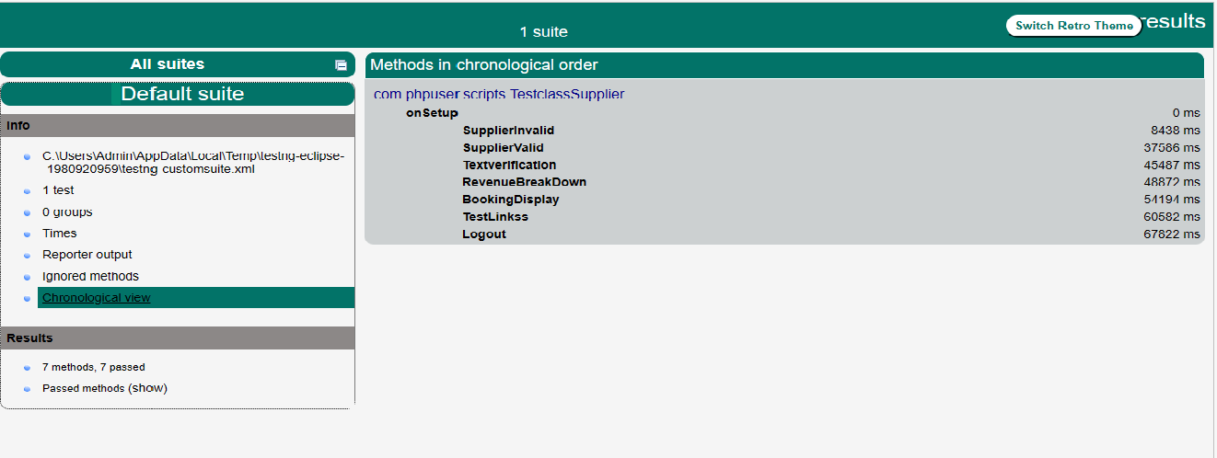

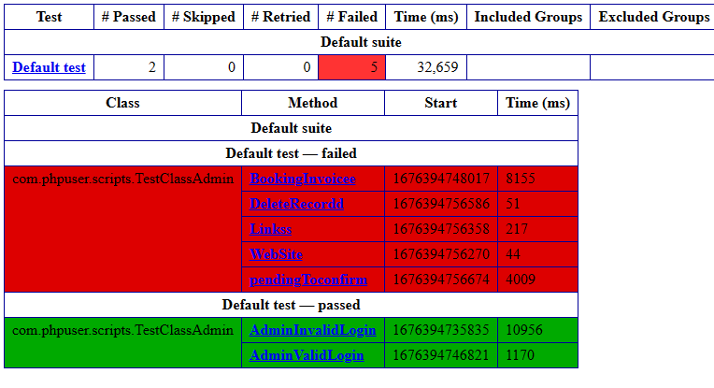

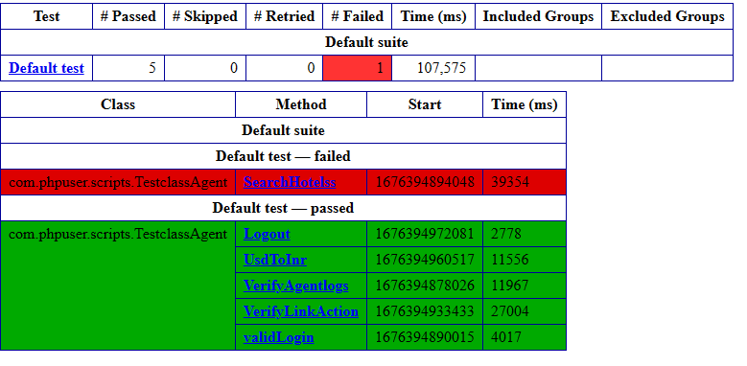  


**Types of testing performed**

**a) Exploratory Testing**

This is an approach to software testing that’s often described as simultaneous learning, test design and execution. It focuses on discovery and relies on the guidance of the individual tester to uncover defects that are not easily covered in the scope of other tests.

**b) System Integration Testing**

This is the Testing performed on the Application under test, to verify the entire application  works as per the requirement Critical Business scenarios were tested to make sure important  Functionalities in the application works as intended without any Errors.

**EXIT CRITERIA**

• All test cases should be executed – Yes

• All defects in Critical, Major, Medium severity should be verified and reported – Yes.

• Any open defects in trivial severity – Action plan prepared with expected dates of closure.

**Conclusion/Sign Off**

As the Exit criteria was met and satisfied as mentioned in Section 10, this application is suggested to ‘Go Live’ by the Testing team. Appropriate User/Business acceptance testing should be performed before ‘Go Live’.